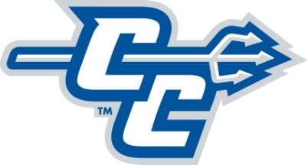

To: Mr. Paul Schlickmann, Director of Athletics
Amy Strickland, Assoc. Athletic Director/Compliance
Coach Name:

From: CCSU ID# :

Date:

RE: Permission to speak with other Four Year Colleges/Institutions (13.1.1.3)

Please be advised that I am requesting a release to speak with other schools under NCAA Bylaw 13.1.1.3. Upon receipt of this form, athletics must grant or deny this request within seven business days. If the institution fails to respond to this written request, permission shall be granted by default and the institution shall provide written permission to the student-athlete.

Please note the following schools to be notified of this release:

Student Athlete Date

Coach Date

Sport Supervisor Date

Compliance Office Date

*Permission to speak with other institutions is separate from the NCAA One-Time Transfer Exception (Bylaw 14.5.5.2.10). To use the One-Time Transfer Exception you must be eligible to return to CCSU under all NCAA, NEC and Institutional rules and regulations. If denied, you will be provided information on how to appeal. Athletes denied will not be able to represent their next school in intercollegiate competition until after serving one year in residence.

Comments (if applicable)

